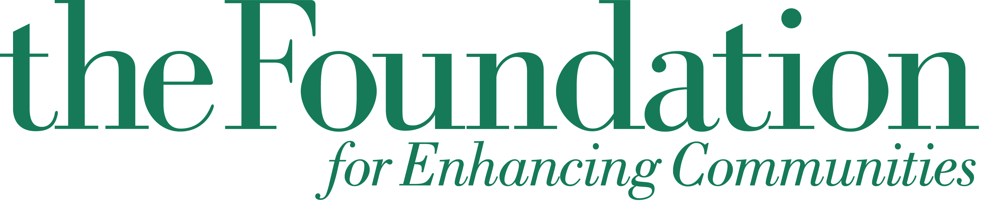
Family & Children’s Services of Lebanon County

a fund of The Foundation for Enhancing Communities

2014 Grantee

Final Grant Evaluation Report
Deadline May 7, 2015

Name of Organization:

Title of Project:

Amount Awarded:

Name & Title of Person Submitting this Report:

Phone: E-Mail:

Please answer the following questions in narrative form using these headings; as they are applicable to your project:
- Did the implemented project differ from what was originally proposed? Please explain.
- What counties were served as part of this project? Check all that apply.

  - Cumberland
  - Dauphin
    - Millersburg Area
  - Franklin
  - Lebanon
  - Perry
  - Northern York (Dillsburg Area)
  - Mifflin
  - Juniata

- Describe the target population served. Please include the number of participants served and their demographic information in the following areas: race/ethnicity/nationality, age, and income level, as applicable.
- Describe the services provided with this funding
- How has this project met the need for the population served? You may benefit from reviewing your answer to the question “Explain the documented need for the project” in your original Proposal Narrative.
- List this project’s original outcomes (goals) as noted on the Program Logic Model submitted with your application.
- List the actual outcomes of this project.
- Did you meet the project goals? If not, please explain in detail why you were unable to meet your goals and what you have learned from the process. What would you change in the future? Were there unexpected outcomes (good or bad)? What were they?
- What was this project’s most notable success? Please include a story that illustrates what you consider to be the most significant impact on the lives of individuals served as a result of the project.
- What was this project’s biggest challenge?
- What steps were taken to ensure the sustainability of your project or organization beyond this grant period?

- The Family and Children’s Services of Lebanon County Fund requires public recognition for this grant. Please indicate any publicity given to the Family and Children’s Services of Lebanon County Fund, a fund of The Foundation for Enhancing Communities as donor. Attach copies of news releases, articles, etc. If publicity was not given, please explain why.
- Complete the Budget Worksheet below. The shaded columns should be directly copied from your original Budget Worksheet as submitted with your grant application. The final two columns (unshaded) should include the actual funding sources & project total. If you have questions about completing this form, please contact Jennifer Kuntch, Program Officer for Community Investment at 717-236-5040.

As listed on your originally submitted Budget Worksheet. |  |  |  |  | Actual Figures
Items | Description of Requested Items | Request to FCS | Outside Funding Sources | Project Total | Actual Funding Sources | Actual Project Total
(EXAMPLE)  Consultant | For four $500.00 training sessions | $2,000 | $5,000 Stewart Foundation | $7,000 | $1,000 TFEC; $3,000 Stewart Foundation; $2,000 Fundraiser & Individual Donations | $6,000
 |  | $ |  | $ |  | $
 |  | $ |  | $ |  | $
 |  | $ |  | $ |  | $
 |  | $ |  | $ |  | $
 |  | $ |  | $ |  | $
 |  | $ |  | $ |  | $
 |  | $ |  | $ |  | $
 |  | $ |  | $ |  | $
Total |  | $ |  | $ |  | $

Signatures (Original Signatures are required):

President/CEO Board President

Submit your completed report to Jennifer Kuntch, Program Officer for Educational Enhancement, at The Foundation for Enhancing Communities, 200 N. 3rd Street, 8th Floor, PO Box 678, Harrisburg, PA 17108-0678.

