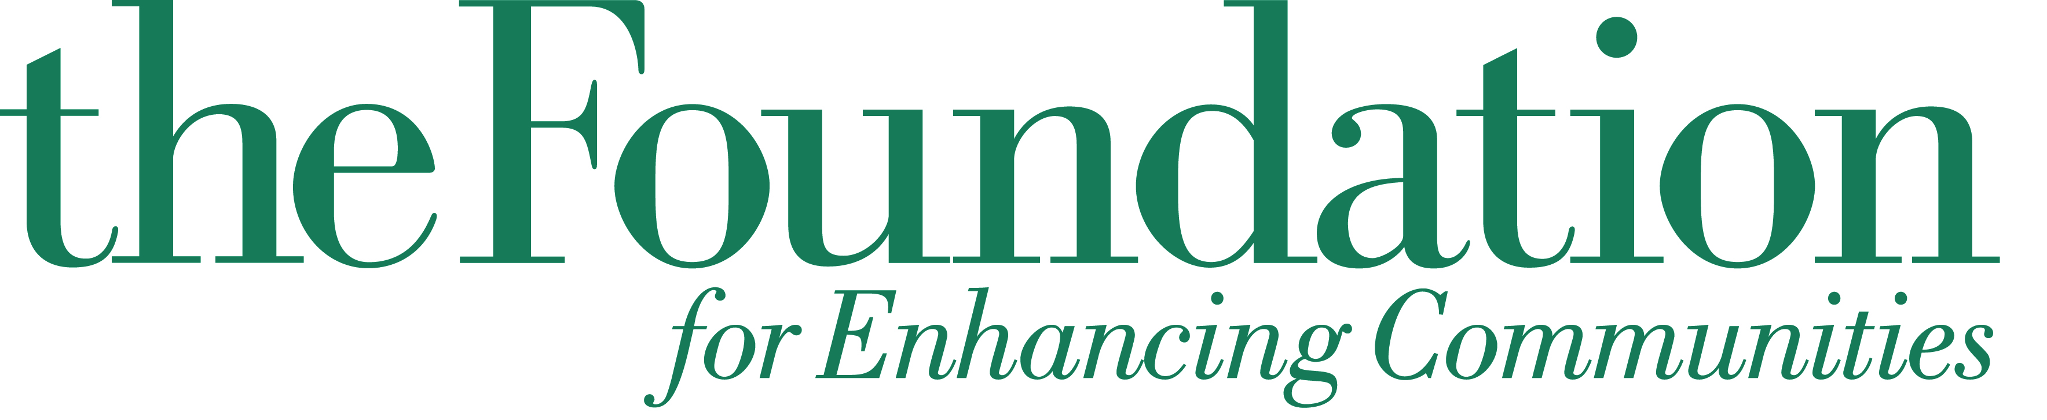
Whitaker Fund for Math & Science Education

a fund of The Foundation for Enhancing Communities

2014 Grantee, Round 2

6 Month “Check-In” E-mail Requirements
Deadline May 6, 2015

E-mail Jennifer Kuntch, Program Officer for Community Investment, at jkuntch@tfec.org with the following information:

- Name of Organization
- Title of Project
- Amount Awarded
- Answer the following questions
  - Is the implementation of the project differing from what was originally proposed in any way? If yes, please explain in detail.
  - Is your project complete?
    - If your project is complete, you may submit the final evaluation. The final evaluation report can be downloaded as Microsoft Word document online at www.tfec.org. Click on For Nonprofits; Evaluation Forms.

