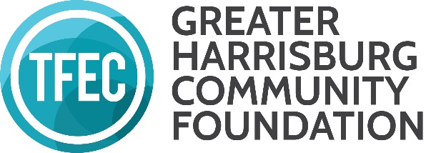
GRANTMAKING ADVISORY COMMITTEE TFEC Grantmaking Staff Contact List

Name: Jennifer Strechay
Title: Program Officer for Community Investment
Email: jstrechay@tfec.org
Phone: 717-236-5040

Name: Andrea Iguina
Title: Community Investment Associate
Email: aiguina@tfec.org
Phone: 717-236-5040

