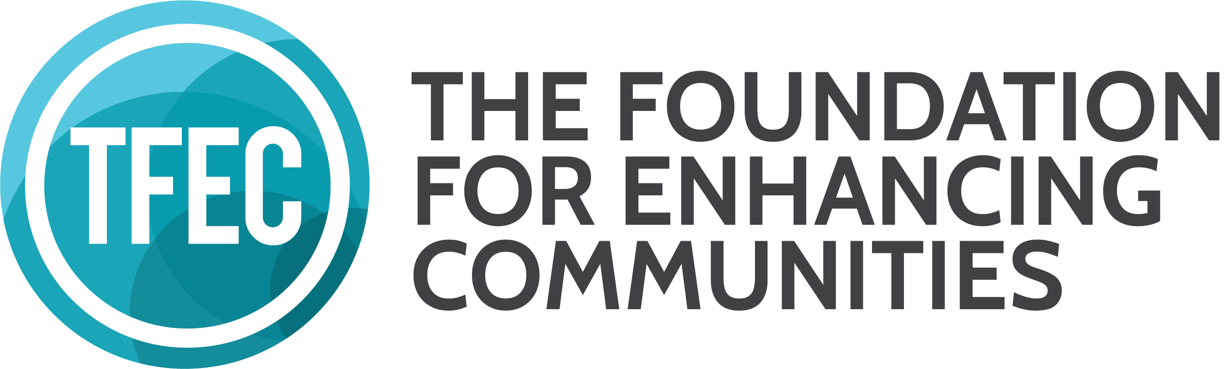This Box is For Office Use Only
Grant #__________________________________
Date Received ___________________________
☐ FIMS ☐ Tracker ☐ Report GRANTEE REQUIREMENT
2018 FINAL EVALUATION FORM

Thank you for completing your Final Evaluation! To comply with your grant award, answer all questions and return all materials by the deadline date listed in your award letter and contract. Once your project is complete, you may submit your Final Evaluation at any time prior to the deadline date. Answer all questions using information that applies to the project supported by grant funds. Please note, failure to comply may impact future grant awards. This form is available at www.tfec.org/nonprofits/evaluation-forms/.

Grantee Name Click or tap here to enter text.

Project Title Click or tap here to enter text.

Grant Number as Stated on Award Contract Click or tap here to enter text.

Grant Award Amount Click or tap here to enter text.

Select Your Award Source Below - this information is in your award letter and contract
☐ Arts for All Partnership ☐ Camp Hill Area Community Foundation
☐ Emerging Philanthropists Program ☐ Franklin County Community Foundation
☐ Family & Children’s Services of Lebanon County Fund ☐ Greater Harrisburg Foundation UPstream
☐ Greater Harrisburg Foundation Benjamin Franklin Fund ☐ Greater Harrisburg Foundation Emergent Needs
☐ The Kids Trust Fund ☐ Martin M. Sacks Memorial Fund
☐ Mechanicsburg Area Community Foundation ☐ Perry County Community Foundation
☐ Patricia L. Murray Fund ☐ The Fund for Women & Girls
Counties served as part of project; check all that apply.
☐ Cumberland ☐ Dauphin ☐ Franklin
☐ Juniata ☐ Lebanon ☐ Mifflin
☐ Millersburg Area (Dauphin) ☐ Northern York (Dillsburg Area) ☐ Perry

# INDIVIDUALS SERVED by project
Click or tap here to enter text. Total number of ADULTS served
Click or tap here to enter text. Total number of CHILDREN (ages 17 and under) served
Click or tap here to enter text. Total number of ALL INDIVIDUALS served by the project
OR
If the above data is not appropriate for your project, be sure to fully state the audience type and numbers served in Question 2 of the Impact Narrative.
Our project is complete and was implemented as stated within our proposal ☐ Yes ☐ No
If no, were changes approved by TFEC staff? ☐ Yes ☐ No
Name, title, email, phone of contact completing report
Click or tap here to enter text.
If application questions arise, this individual will be contacted by TFEC staff.
IMPACT SNAPSHOT
1. Capture your project and the community need it addressed in 200 words or less.

Click or tap here to enter text.
IMPACT NARRATIVE
Answer questions 2-5 clearly and concisely; no limit.
2. In your application you described what would happen, who would be served, and other details. Now, please state what actually happened, who was served by your project, the dates and locations during which the project took place (as appropriate to the project) and the names and roles of any organizations that were relevant to the project. Did the implemented project differ from what was proposed in any way? Explain in detail. You MUST use and complete the following statement within your answer, “Grant funds were used to____________”.

Click or tap here to enter text.

3. In your original application you provided a brief overview of your project’s projected outcomes and stated how you would measure and document success. Using this as a guide, what measurable impact did the project have on the community and how did you measure success?

Click or tap here to enter text.

4. Describe one success and one challenge experienced in implementing your project; state how the challenge was addressed.

Click or tap here to enter text.

5. In the format that best fits your needs (writing in sentence format below, using an attached chart, or by providing a copy of a financial document, etc.) provide an outline of actual expenditures compared to the budgeted expenditures for the project. You MUST indicate the amount of grant funding received and where grant funds were applied. Following this page, attach copies of all receipts/invoices paid with grant proceeds as appropriate to your project (ie: items purchased with grant funds, payment for specific services). When providing copies of receipts/invoices paid, we understand that it may not be possible to provide a receipt for all items; provide what is appropriate to your project.

Click or tap here to enter text.
SIGN & SUBMIT
Both signatures are required; original signatures are required.

Click or tap here to enter text.
- President/CEO ____________________________________________________________________
Original Signature Printed Name

Click or tap here to enter text.
- Board President ____________________________________________________________________
Original Signature Printed Name

REQUIREMENTS TO BE MAILED OR DELIVERED BY 4PM ON THE DEADLINE DATE
- A completed Final Evaluation and Sign & Submit form (this page) with original signatures.
- Copies of all receipts/invoices paid with grant proceeds as appropriate to your project (ie: items purchased with grant funds, payment for specific services). When providing copies of receipts/invoices paid, we understand that it may not be possible to provide a receipt for all items; provide what is appropriate to your project.
- Optional materials that you may wish to share with us: Photos or other materials (do not staple) that demonstrate your success; include Media Release and Photo Copyright Form(s) as needed.

SUBMIT ALL FINAL EVALUATION MATERIALS VIA MAIL OR DELIVERY TO:
- Mailing Address
The Foundation for Enhancing Communities
Attn: Jennifer Strechay
PO Box 678
Harrisburg, PA 17108-0678

- Physical Address
The Foundation for Enhancing Communities
Attn: Jennifer Strechay
200 North 3rd Street, 8th Floor
Harrisburg, PA

QUESTIONS
If you should have any questions regarding this form or TFEC grant opportunities, contact Jennifer Strechay, Program Officer for Community Investment, at jstrechay@tfec.org or 717-236-5040.

