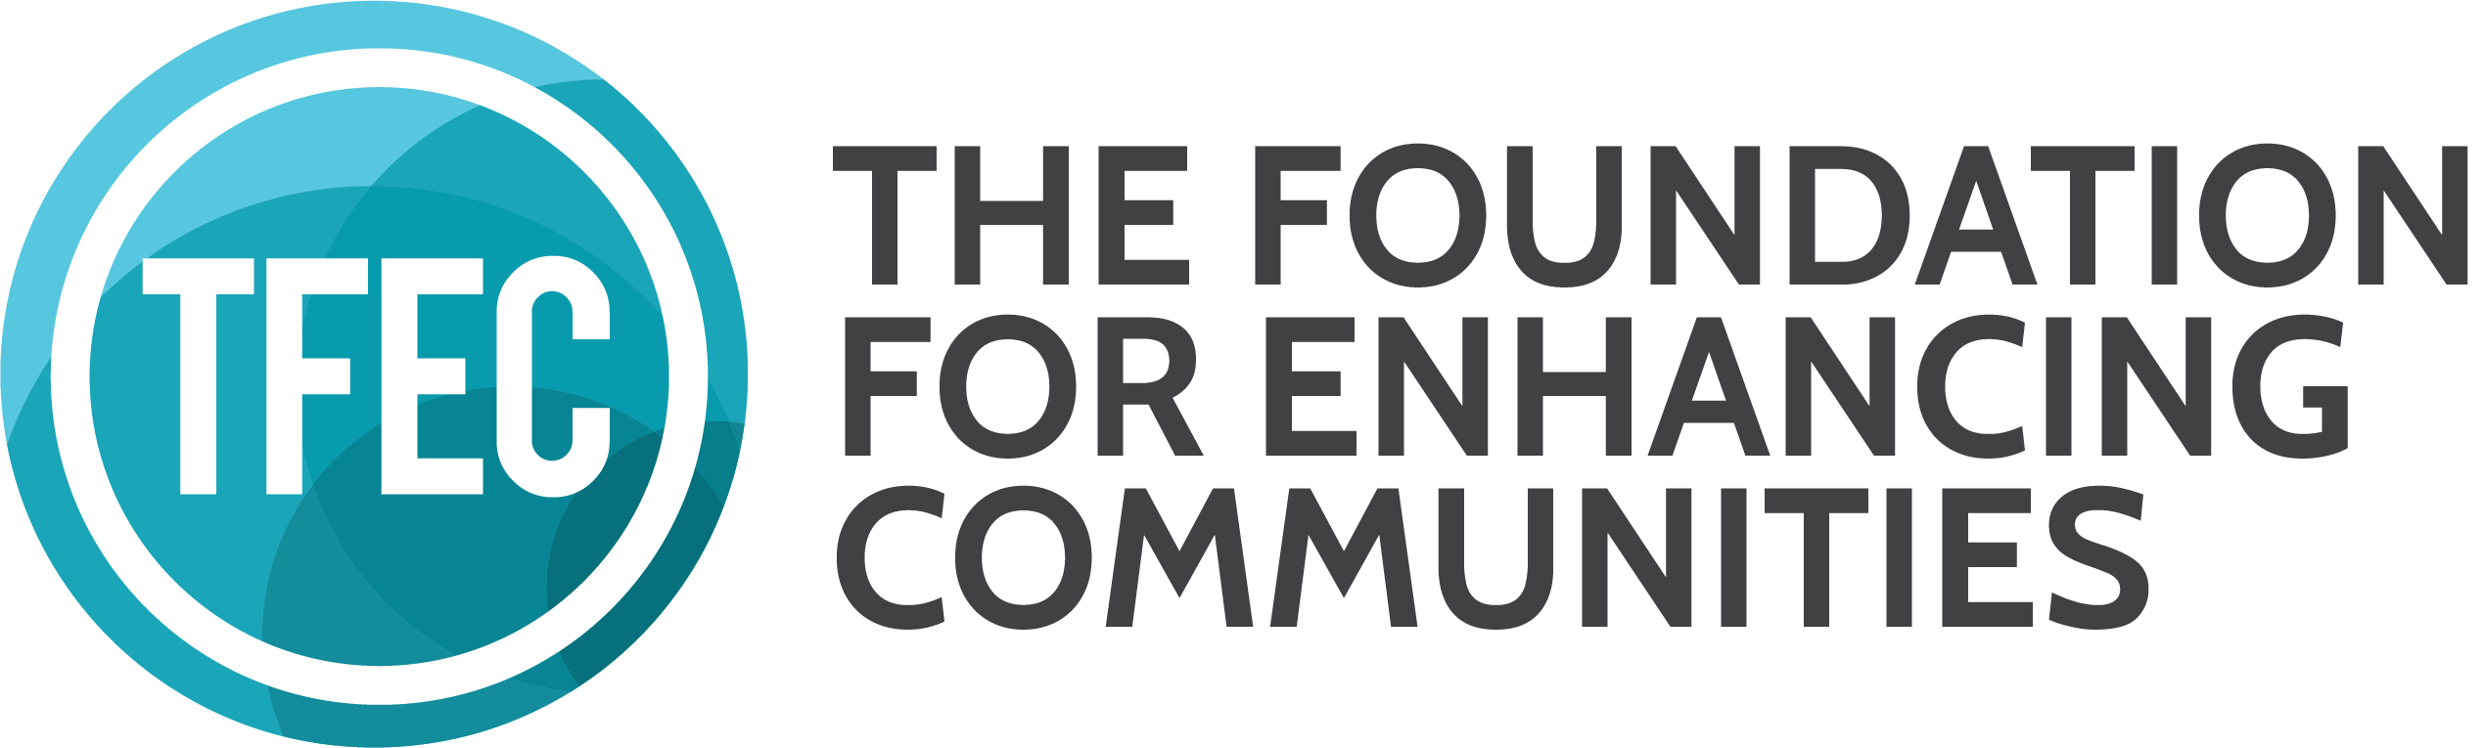CHILDREN’S HOME FOUNDATION
APPLICATION FOR FUNDING COVER PAGE

To complete the Application for Funding Cover Page type into the provided fields. Use your preferred word processing program to answer all other questions. A complete application consists of the Application for Funding Cover Page; a narrative of five pages maximum (exclusive of attachments) answering the questions below; and the required attachments. Completed applications may be emailed to grants@tfe.corg or mailed to The Foundation for Enhancing Communities, PO Box 678, Harrisburg, PA 17108-0678. Emailed applications must be submitted by 4pm on the deadline date. Mailed applications must be postmarked by the deadline date. Contact Jennifer Strechay, Program Offer for Community Investment, at jstrechay@tfec.org or 717-236-5040 with questions.

Name of Organization Click or tap here to enter text.

Name, Title, Email, Phone of Executive Leader Click or tap here to enter text.

Organization Mailing Address Click or tap here to enter text.

Website Click or tap here to enter text.

Name, Title, Email Phone of Application Contact Click or tap here to enter text.

Amount of Funding Requested Click or tap here to enter text.

Purpose of Funding Request Click or tap here to enter text.

Briefly describe your organization
A. Mission, purpose, and history.
B. Service population and geographic area served, including demographics.
C. Current programs, activities, and accomplishments.

Briefly describe the project for which you are requesting funding
A. Project goals, objectives, and planned activities/events.
B. Project timetable and budget. The project budget is separate from the organization budget.
C. Constituency served or targeted population.
D. Other funding sources and amounts.
E. Project benefits and anticipated results.
F. Description of how project differs from similar projects in geographic area served.

Required Attachments
A. Board of Directors List.
B. Applicant organization’s current budget.
C. First page of the applicant organization’s most recent 990. If 990 is not available, provide the most recent audit or financial statement to meet this need.
D. 501(c) (3) Letter or proof of application.
E. Copy of your registration with the Pennsylvania Bureau of Charitable Organizations.

Please Note: Letters of support are not required, but are accepted. If your project represents a partnership or is 100% dependent upon participation by an organization presented in your application, provide a letter from each organization that confirms their agreement to participate. If your project utilizes a Fiscal Sponsor, follow the Fiscal Sponsor instructions at https://www.tfec.org/grants/the-childrens-home-foundation-fund-grant-guidelines/.

