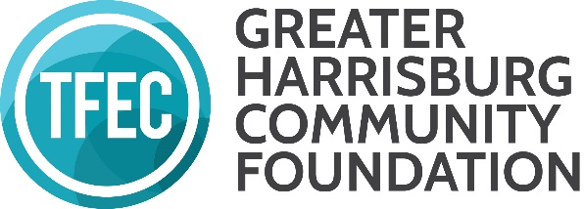
GRANTMAKING ADVISORY COMMITTEE 2020 Grantmaking Meeting Dates

The following GHCF Grantmaker meetings are confirmed and will take place in Fall 2020:
- GHCF Grantmaker Overview & Business Meeting: September 22, 2-3:30 pm (an overview of the materials you will be reading + any business needs)
- GHCF Grantmaking Meeting One (UPstream): October 27, 1-3:30pm, TFEC
- GHCF Grantmaking Meeting Two (UPstream & Benjamin Franklin Fund): November 5, 1-3:30pm, TFEC
*At this time, we anticipate that all meetings will take place in person at TFEC, but should that not be possible, they will take place via ZOOM and we will reach out to the group with all needed information.

