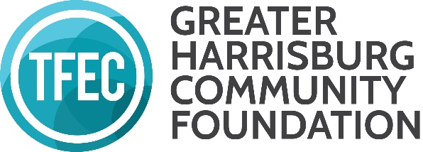
GRANTMAKING ADVISORY COMMITTEE Overview of Work & Duties

The Greater Harrisburg Community Foundation Grantmaking committee’s membership is comprised of individuals who are representative of the geographic region that TFEC serves. This committee is charged with overseeing the discretionary grant program of the Greater Harrisburg Community Foundation, a regional foundation of TFEC, which includes the Arts for All Partnership (this is a separate committee, but the GHCF committee may be asked to approve funds to the Arts for All Partnership), Greater Harrisburg Community Foundation Benjamin Franklin Trust Fund, Greater Harrisburg Community Foundation Early Childhood Initiative, and Greater Harrisburg Community Foundation UPstream Grants. Upon reaching consensus, the committee makes recommendations to the TFEC Board of Directors on grants from the unrestricted and area of interest funds of the Greater Harrisburg Community Foundation in line with the grant guidelines of the Committee. Duties of the committee include reviewing applications, evaluating grantee progress, remaining aware of the communities’ needs, revising grant guidelines when appropriate, and maintaining positive relationships with other community partners. The GHCF grantmaking committee is also notified by TFEC staff of funds awarded through the Emergent Needs grant opportunity, which may award up to $5,000 to address nonprofit emergency needs. The Committee meets two to four times per year and as needed.

