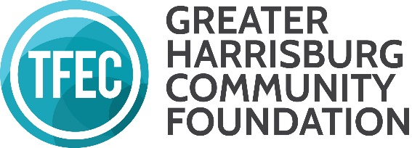
GRANTMAKING ADVISORY COMMITTEE Advisory Committee Charter

PURPOSE
The Greater Harrisburg Community Foundation (GHCF) Advisory Committee is charged with overseeing the discretionary grant program of the Greater Harrisburg Community Foundation, a regional foundation of The Foundation for Enhancing Communities. GHCF serves the entire TFEC service area of Cumberland, Dauphin, Franklin, Lebanon, Perry Counties and the Dillsburg area of northern York County. GHCF currently oversees the following grant opportunities:

- Arts for All Partnership (separate advisory committee)
- Early Childhood Strategic Initiative: Phases 1, 2, and 3
- Emergent Needs
- GHCF UPstream
- Patricia L. Murray Fund (non-publicized; utilizes GHCF funds, but is administered by TFEC staff at this time due to fund instruction and named grantees)

SERVICE
Committee service includes the evaluation of grant applications, and upon reaching consensus, making recommendations to the TFEC Board of Directors on discretionary grants from the unrestricted and area of interest funds of GHCF. The Committee will be guided by the grant guidelines of each GHCF grant initiative and is responsible for revising grant guidelines when appropriate, overseeing evaluation of funded proposals, being aware of community needs and innovative programs, ensuring grants are distributed according to donor intent, and maintaining positive relationships with community partners.

In addition, the Committee will:
- Advocate for TFEC in the community and participate in the long-term stewardship of our community.
- Engage TFEC Board members and others in the community on the value and impact GHCF grants have in the community.
- Serve as ambassadors for unrestricted giving.
- Serve as a resource to the TFEC team in connection with objectives, provide expertise and information, and participate in events, programs, and activities.
- On the periphery, assist the TFEC team in identifying unrestricted and area of interest donor prospects, and when necessary, participate in prospect visits.
- Coordinate efforts with other TFEC committees when necessary, such as the Communications Committee.

STRUCTURE
The Chair of the TFEC Board of Directors may designate a GHCF Grantmaking Committee of a minimum of nine members who are representative of the geographic region that GHCF serves subject to approval of the Board of Directors. The Chair of the TFEC Board will appoint the Committee’s Chair and additional members subject to approval of the Board of Directors. Non-Board members may be appointed based upon their expertise and knowledge of the community. The Committee will utilize term limits; a term is three years and a second consecutive term of three years can be served. The Committee meets two to four times per year and as needed. The Committee will provide regular activity reports to the Board of Directors. The Program Officer for Community Investment will staff the Committee, and the Vice President of Philanthropy & Community Investment and the President/CEO will serve as members. Other TFEC personnel may attend committee meetings as needed.

Advisory Committee Member Signature: ________________________________ Date: Click or tap to enter a date.

