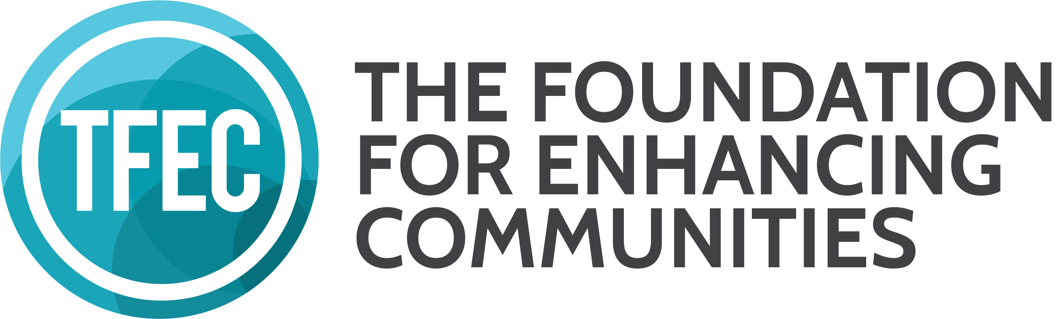
CHILDREN’S HOME FOUNDATION
APPLICATION FOR FUNDING COVER PAGE

A completed copy of this cover page must accompany all applications for funding directed to the Children’s Home Foundation Fund, a fund of The Foundation for Enhancing Communities. Please provide the following information in a narrative of five pages maximum, exclusive of attachments. Completed applications may be mailed or hand delivered to the following addresses and must be received by–not postmarked by–4pm on the respective deadline date. MAILING ADDRESS: The Foundation for Enhancing Communities, PO Box 678, Harrisburg, PA 17108-0678. PHYSICAL ADDRESS: The Foundation for Enhancing Communities, 200 North 3rd Street, 8th Floor, Harrisburg, PA. Contact Jennifer Strechay, Program Offer for Community Investment, at jstrechay@tfec.org or 717-236-5040 with questions.

Name of Organization Click or tap here to enter text.

Name and Title of Executive Leader Click or tap here to enter text.

Mailing Address Click or tap here to enter text.

Telephone Click or tap here to enter text.

Website Click or tap here to enter text.

Name and Title of Contact Click or tap here to enter text.

Email Address of Contact Click or tap here to enter text.

Amount of Funding Requested Click or tap here to enter text.

Purpose of Funding Request Click or tap here to enter text.

Briefly describe your organization:
A. Mission, purpose, and history
B. Service population and geographic area served, including demographics
C. Current programs, activities, and accomplishments

Briefly describe the project for which you are requesting funding:
A. Project goals, objectives, and planned activities/events
B. Project timetable and budget; the project budget is separate from the organization budget
C. Constituency served or targeted population
D. Other funding sources and amounts
E. Project benefits and anticipated results
F. Description of how project differs from similar projects in geographic area served.

Additional Information Required:
A. List of your current Board of Directors
B. Copy of your organization’s current budget AND first page of the organization’s 990. If 990 is not available,
provide applicant organization’s most recent audit or financial statement.
C. Copy of your 501(c) (3) Letter or proof of application
D. Copy of your registration with the Pennsylvania Bureau of Charitable Organizations
E. While Letters of Support are NOT REQUIRED for this grant opportunity, they may be submitted with your grant materials. If your project represents a partnership or is 100% dependent upon participation by an organization presented in your application, please provide a letter from each organization that confirms their agreement to participate in the project.

